EE 203 PROBABILITY AND RANDOM VARIABLES

HOMEWORK – 1

- Show that
_____ _____
a) Ā U Ē U Ā U E = A.
____ _ _
- (A U E) (A E) = A E U E A .
___
- If A = { 2 ≤ x ≤ 5 } and B = { 3 ≤ x ≤ 6 } , find A U B, AB and (A U B)(AB).
_
- Show that if AB = { Ø }, then P(A) ≤ P(B).

- Show that
_ _
  - If P(A) = P(B) = P(AB), then P(AB U BA) = 0.

  - If P(A) = P(B) = 1, then P(AB) = 1.

- Prove and generalize the following identity

P(A U B U C) = P(A) + P(B) +P(C) - P(AB) - P(AC) - P(BC) + P(ABC)

- If S = { 1, 2, 3, 4 }, find the smallest field that contains the sets { 1 } and

{2, 3 }.

- If A ⊂ B, P(A) = ¼ and P(B) = 1/3, find P(A | B) and P(B | A).

- Show that

  - P(AB | C) = P(A | BC) P(B | C).

  - P(ABC) = P(A | BC) P(B | C) P(C).

- A call occurs at time t where t is a random point in the interval (0, 10).

  - Find { 6 ≤ t ≤ 8 }.

  - Find { 6 ≤ t ≤ 8 | t > 5 }.

- The events A and B are mutually exclusive. Can they be independent ?

ECE 307 PROBABILITY AND RANDOM PROCESSES

ANSWERS TO HOMEWORK – 1

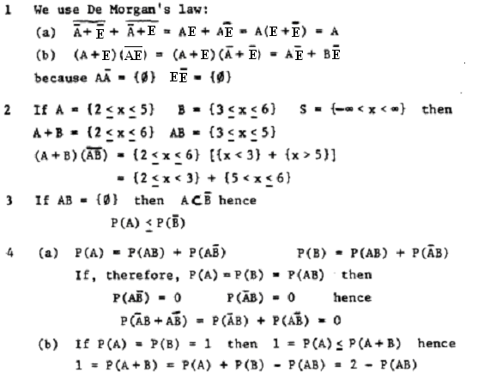

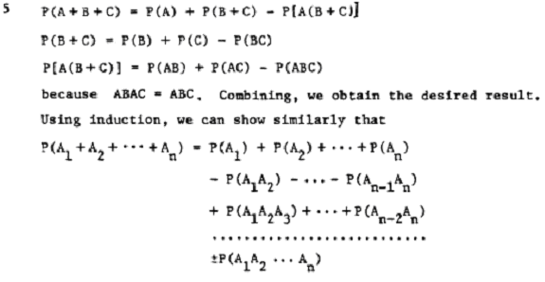
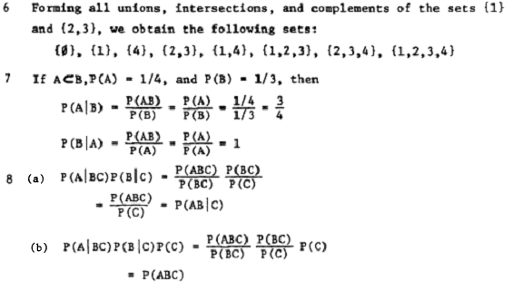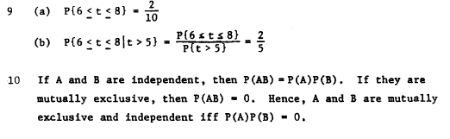

ECE 307 PROBABILITY AND RANDOM PROCESSES

HOMEWORK – 2

  - Ten passengers get into a train that has 3 cars. Assuming a random placement of passengers, what is the probability that the first car will contain three of them?

  - Box 1 contains 1000 bulbs of which 10% are defective. Box 2 contains 2000 bulbs of which 5% are defective. Two bulbs are picked from a randomly selected box.

- Find the probability that both bulbs are defective.
- Assuming that both are defective, find the probability that they came from box 1.

  - We have two coins; the first is fair and the second is two-headed. We pick one of the coins at random, we toss it twice and heads shows both times. Find the probability that the coin picked is fair.

  - Box 1 contains 1 white and 999 red balls. Box 2 contains 1 red and 999 white balls. A ball is picked from a randomly selected box. If the ball is red what is the probability that it came from box 1?

  - Let p represent the probability of an event A. What is the probability that

- A occurs at least twice in n independent trials?
- A occurs at least three times in n independent trials?

  - A pair of dice is rolled 50 times. Find the probability of obtaining double six at least three times?

  - Consider the following three events: (a) At least 1 six is obtained when six dice are rolled, (b) at least 2 sixes are obtained when 12 dice are rolled, and (c) at least 3 sixes are obtained when 18 dice are rolled. Which of these events is more likely?

  - Suppose there are r successes in n idependent Bernoulli trials. Find the conditional probability of a success on the i th trial.

  - If x is N (1000, 400) find (a) P{ x < 1024 }, (b) P{ x < 1024 | x > 961 }, and (c) P{ 31 < (x)^{1/2} ≤ 32 }.

  - We measure for resistance R of each resistor in a production line and we accept only the units the resistance of which is between 96 and 104 ohms. Find the percentage of the accepted units (a) if R is uniform between 95 and 105 ohms; (b) if R is normal with η = 100 and σ = 4 ohms.
ECE 307 PROBABILITY AND RANDOM PROCESSES

ANSWERS TO HOMEWORK – 2

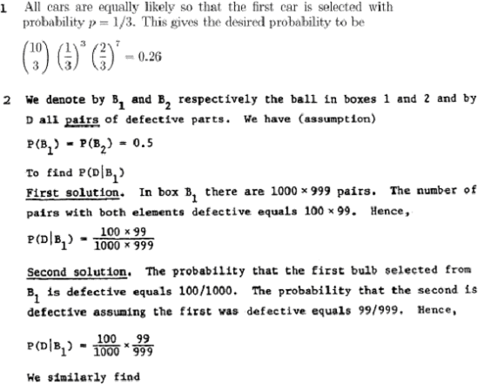

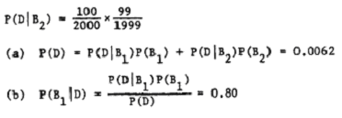
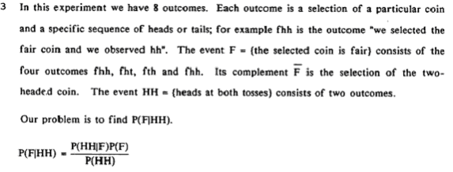
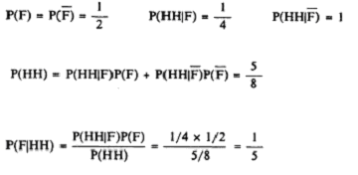
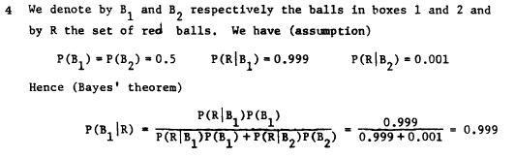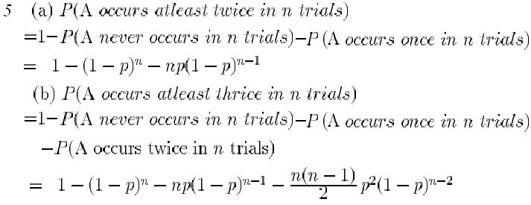

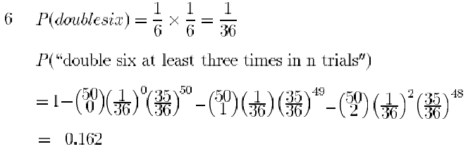
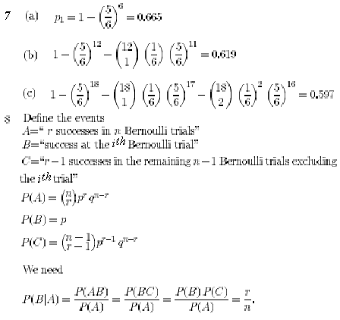
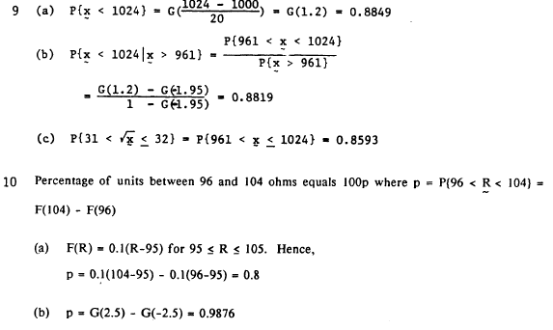

b yanlış mı?

ECE 307 PROBABILITY AND RANDOM PROCESSES

HOMEWORK – 3

  - Given that F (x _{u}) = u. Show that if f (-x) = f ( x), then x _{1-u} = - x _{u} .

  - Find f (x) if F (x) = [1 - exp ( - α x) ] U (x - c).

  - A fair coin is tossed three times and the random variable x equals the total number of heads. Find and sketch F_{x} (x) and f _{x} (x).

  - Show that, if a ≤ x (ζ) ≤ b for every ζ Є Ω, then F(x) = 1 for x > b and F(x) = 0 for x <a.

  - For a random variable X of N (0,100)

    - Find P (X ≤ 0)
    - Find x at which F_{x} (x) =1 / 2

  - For a continuous random variable X whose probability density function is even

    - Find P ( 0 < X ≤ 4) if P ( - ∞ < X ≤ - 4) = 0.3.
    - Find F_{x} (4).

  - For question-3,

    - Find P ( x ≤ 2) and P ( x < 2) by using f _{x} (x).
    - Repeat a. By using F_{x} (x).

  - A coin is tossed an infinite number of times. Find the probability that k heads are observed at the n ^{th} toss but not earlier.

  - Show that F_{x} ( x | A) = P (A | x ≤ x) F_{x} ( x ) / P(A)

  - Over a period of 10 hours, 100 calls are made at random. What is the probability that in a 2-hour interval the number of calls is between 30 and 40 ?

ECE 307 PROBABILITY AND RANDOM PROCESSES

ANSWERS TO HOMEWORK – 3

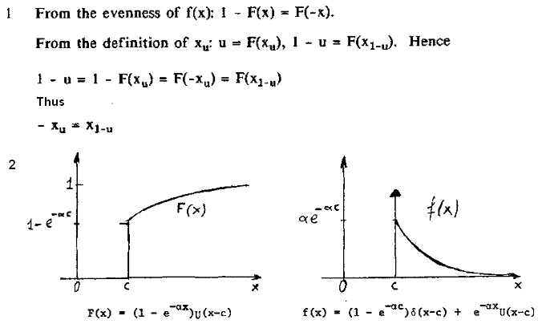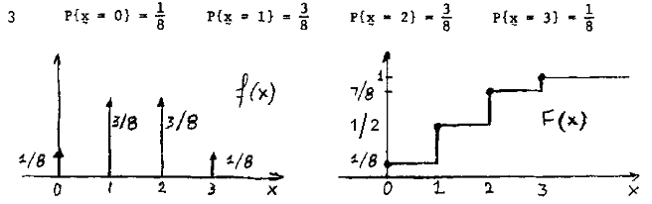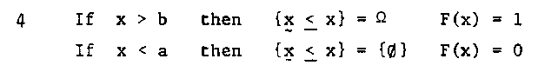
5. a. P (X ≤ 0) = ½

b. x = 0

6. a. P ( 0 < X ≤ 4) = (1- 2 x 0.3) / 2 = 0.2
b. F_{x} (4) = P ( X ≤ 4 ) = P ( - ∞ < X ≤ 0) + P ( 0 < X ≤ 4) = 0.5 + 0.2 = 0.7

7. a. P ( x ≤ 2) = f _{x} (0) + f _{x} (1) + f _{x} (2) = 1/8 + 3/8 + 3/8 = 7/8
P ( x < 2) = f _{x} (0) + f _{x} (1) = 1/8 + 3/8 = 1/2
b. P ( x ≤ 2) = F_{x} (2 ⁺) = 7/8 and P( x < 2) = F_{x} (2 ⁻) = 1/2.

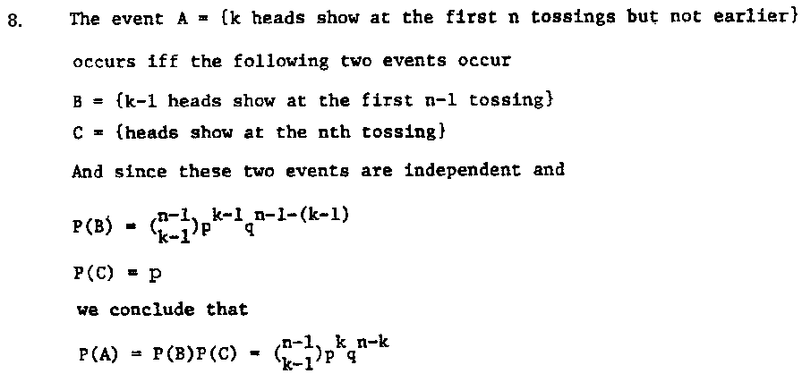
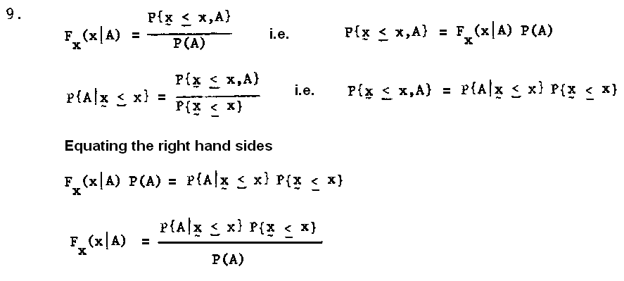 10. p = 2 / 10 = 1 / 5

The probability that k calls will occur in a 2-hour interval = 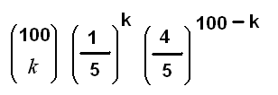

The probability that in a 2-hour interval the number of calls is between 30 and 40

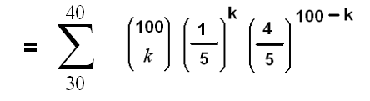

ECE 307 PROBABILITY AND RANDOM PROCESSES

HOMEWORK – 4

  - The random variable x is N(5,4) and y = 2x + 4. Find η_{y} , σ_{y}².

  - Find F_{y}(y) and f_{y}(y) if F_{x}(x) = (1 – e ^{– 2 x} )U(x) and y = x ².

  - Find F_{y}(y) in terms of F_{x}(x) if

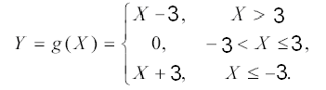

  - For the Question 3 above, find f_{y}(y) in terms of f_{x}(x).

  - The random variable x is uniform in the interval (0, 1). Find the density of the random variable y = - ln x .

  - Find f_{y}(y) in terms of f_{x}(x) if y = | x |.

  - Repeat Question 6 above if

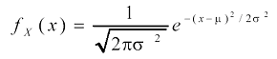

  - The random variable x has mean value η_{x} and variance σ_{x}². If y = ax+b, find the mean value and the variance of the random variable y in terms of η_{x} and σ_{x}².

  - If x is a binomial random variable with parameters n and p. Find E(x) and E[x (x - 1) ].

  - Find E(x ²) and σ_{x}² for x given in Question 9 above.

ECE 307 PROBABILITY AND RANDOM PROCESSES

ANSWERS TO HOMEWORK – 4


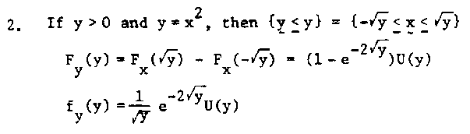
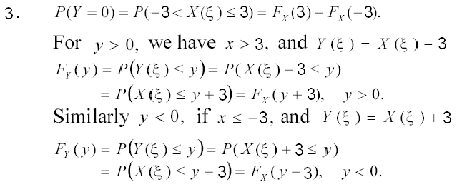
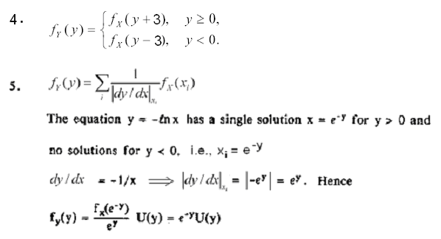
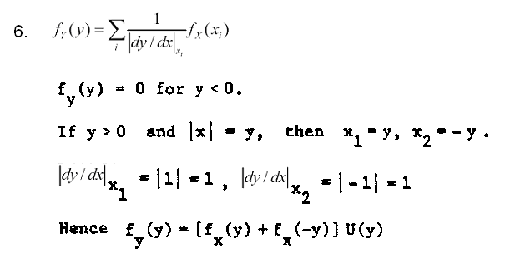
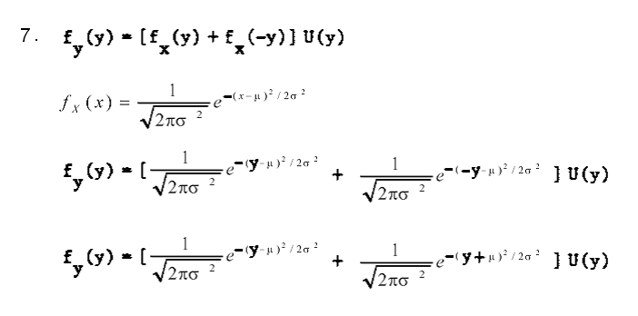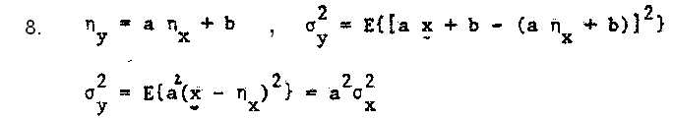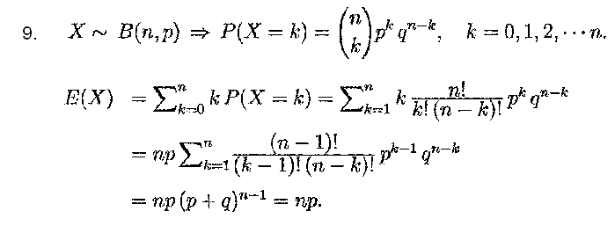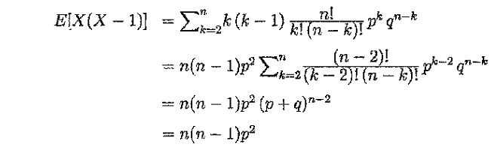
10. E(X ²) = E [ X (X - 1 ) ] + E(X ) = n ( n - 1) p² + np

= n² p² - n p² + np = n² p² + np (1 - p ) = n² p² + npq

σ_{x}² = E(X ²) - [ E(X) ] ² = n² p² + npq - n² p² = npq

ECE 307 PROBABILITY AND RANDOM PROCESSES

HOMEWORK – 5

- The characteristic function of a binomial random variable X is given by

Φ_{X} (ω) = ( p e ^{j} ^{ω} + q ) ^{n} . Find E(X) and σ${}_{X}^{2}$.

- Find the characteristic function of a Gaussian r.v. X

3. X and Y are jointly normal (Gaussian) distributed if their joint p.d.f. has the following form:
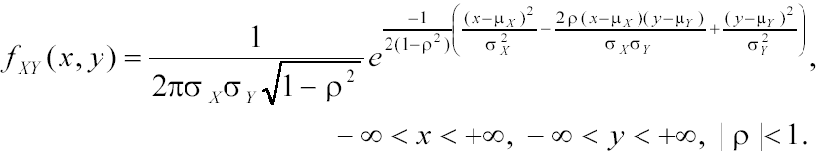 It can be shown that
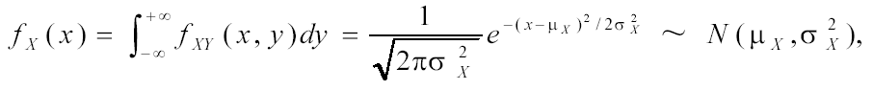 and similarly
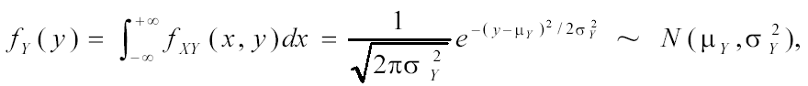
Write f _{xY} (x,y) for ρ = 0.

- Are the r.v. s X and Y given in the above Question 3 independent in general ? For what values of ρ are they independent ?

- Given the joint p.d.f as
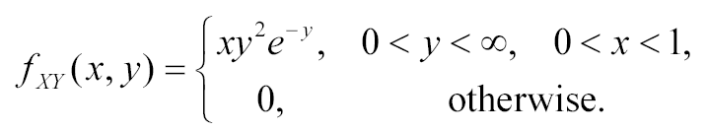
Determine whether X and Y are independent.

- The exponential random variable X ~ ε(λ) has the probability density function f _{X} (x) = λ e ^{–λx}, x ≥ 0, λ > 0. Find the mean, variance and the characteristic function of ε (λ).
- X, Y are jointly normal (Gaussian) random variables which are independent. μ_{x} = μ_{y} = 0 and σ${}_{x}^{2}$ = σ${}_{Y}^{2}$ = 1. Find P(-∞ < X < 0, -∞ < Y < 0).
- Repeat the above Question 7, if μ_{x} = μ_{y} = 0 and σ${}_{x}^{2}$ = σ${}_{Y}^{2}$ = 100.
- f _{XY} (x,y) = 2 / (π b), 0 ≤ x ≤ b, 0 ≤ y ≤ π / 2. Find marginal p.d.f. s
- Find E(X) if Φ_{X} (ω) = [1 / ( j ω ) ] [ - 1 + exp (j ω)]

ECE 307 PROBABILITY AND RANDOM PROCESSES

ANSWERS TO HOMEWORK – 5

- For the binomial random variable X

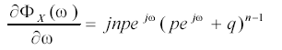
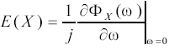
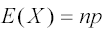
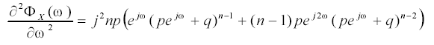
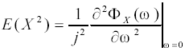
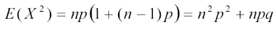
- For Gaussian r.v. X 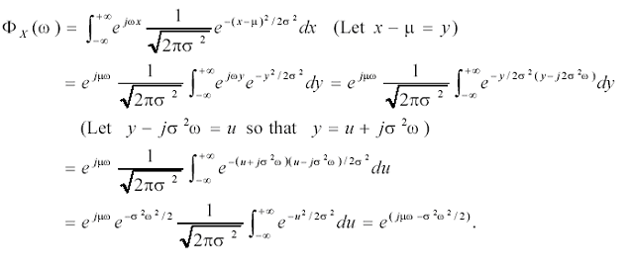3. For ρ = 0
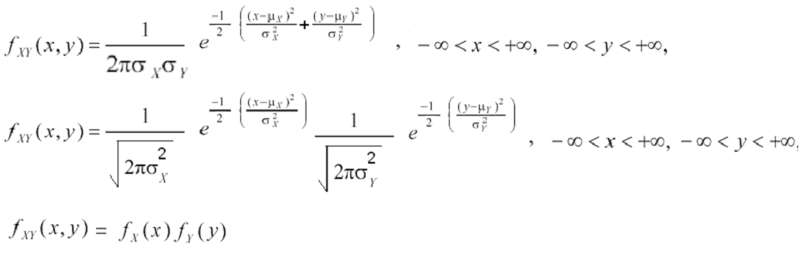
4. The r.v. s X and Y given in the above Question 3 are not independent in general. It is shown in the answer to Question 3 that they are independent for ρ = 0.

5. First evaluate the marginal p.d.f. s
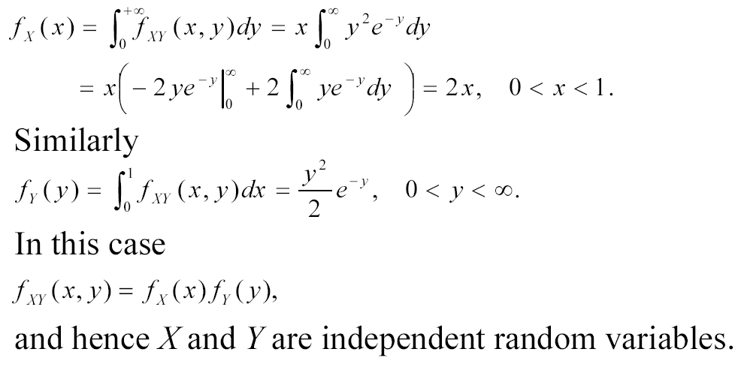
6. Mean = E(X) = x f _{X} (x) dx =x λ e ^{–λx} dx = λx e ^{–λx} dx
Let u = x, dv = e ^{–λx} dx ⇨ du = dx, v = - (1 / λ) e ^{–λx}
E(X) = λx e ^{–λx} dx = λ [uv |${}_{0}^{∞}$ - v du]
= λ [ - x (1 / λ) e ^{–λx} |${}_{0}^{∞}$ + (1 / λ) e ^{–λx} dx ]
= λ [ 0 + (1 / λ)(- 1 / λ) e ^{–λx} |${}_{0}^{∞}$] = 1 / λ
E(X ²) = x² f _{X} (x) dx = x² λ e ^{–λx} dx = λ x² e ^{–λx} dx
Let u = x², dv = e ^{–λx} dx ⇨ du = 2xdx, v = - (1 / λ) e ^{–λx}

E(X ²) = λ x² e ^{–λx} dx = λ [uv |${}_{0}^{∞}$ - v du]
= λ [ - x² (1 / λ) e ^{–λx} |${}_{0}^{∞}$ + (1 / λ) 2x e ^{–λx} dx ]
= λ [ 0 + ( 2 / λ)x e ^{–λx} dx ] = λ [ ( 2 / λ) (E(X) / λ) ] = 2 / λ²
Variance = σ${}_{x}^{2}$ = E( [X - E(X) ] ² ) = E(X ²) - [ E(X) ] ²
= 2 / λ² - (1 / λ) ² = 1 / λ²
Characteristic function = Φ_{X} (ω) = E (e ^{j x ω}) = e ^{j x ω} f _{X} (x) dx
Φ_{X} (ω) = e ^{j x ω} λ e ^{–λx} dx = λe ^{(j ω – λ)x} dx = λ / (j ω – λ) e ^{(j ω – λ)x} |${}_{0}^{∞}$
= λ / (j ω – λ) (0-1) = - λ / (j ω - λ) = 1 / (1- j ω / λ)

7. P(-∞ < X < 0, -∞ < Y < 0) = F_{XY} (0,0) - F_{XY} (0, -∞) - F_{XY} (-∞,0) + F_{XY} (-∞,-∞)

Since X,Y are independent, F_{XY} (x,y) = F_{X} (x) F_{Y} (y)

So P(-∞ < X < 0, -∞ < Y < 0) = F_{X} (0) F_{Y} (0) - F_{X} (0) F_{Y} (-∞) - F_{X} (-∞) F_{Y} (0)
+ F_{X} (-∞) F_{Y} (-∞)
= (1/2) (1/2) - (1/2)(0) - (0) (1/2) + (0) (0) = 1/4
8. P(-∞ < X < 0, -∞ < Y < 0) = F_{XY} (0,0) - F_{XY} (0, -∞) - F_{XY} (-∞,0) + F_{XY} (-∞,-∞)

Since X,Y are independent, F_{XY} (x,y) = F_{X} (x) F_{Y} (y)

So P(-∞ < X < 0, -∞ < Y < 0) = F_{X} (0) F_{Y} (0) - F_{X} (0) F_{Y} (-∞) - F_{X} (-∞) F_{Y} (0)
+ F_{X} (-∞) F_{Y} (-∞)
= (1/2)(1/2) - (1/2)(0) - (0)(1/2) + (0)(0) = ¼, i.e. the same probability
as in the above Question 7.

- f _{XY} (x,y) = 2 / (π b), 0 ≤ x ≤ b, 0 ≤ y ≤ π / 2
f _{X} (x) = f _{XY} (x,y) dy = 2 (π b)⁻¹ dy = 2 (π b)⁻¹ y |${}_{0}^{π/2}$
= 1 / b, 0 ≤ x ≤ b
f _{Y} (y) = f _{XY} (x,y) dx = 2 (π b)⁻¹ dx = 2 (π b)⁻¹ x |${}_{0}^{b}$
= 2 / π, 0 ≤ y ≤ π / 2
10. E(X ^{k}) = (1 / j ^{k}) [∂^{k}Φ_{X} (ω) / ∂ω^{k} ] | _{ω=0}

E(X) = (1 / j ) [∂Φ_{X} (ω) / ∂ω ] | _{ω=0}

Φ_{X} (ω) = [1 / ( j ω ) ] [ - 1 + exp (j ω) ]
[
∂Φ_{X} (ω) / ∂ω] = { ( j ω) j exp (j ω) - j [ - 1 + exp (j ω) ] } / (-ω²)

[∂Φ_{X} (ω) / ∂ω ] | _{ω=0} = 0 / 0

Thus differentiating the numerator and the denominator to find the limit

[∂Φ_{X} (ω) / ∂ω ] | _{ω=0} = { - j ω exp (j ω) - exp (j ω) + exp (j ω) } / (-2ω)

= { - j ω exp (j ω) } / (-2ω) = 0 / 0
Again differentiating the numerator and the denominator

[∂Φ_{X} (ω) / ∂ω ] | _{ω=0} = - j { j ω exp (j ω) + exp (j ω) } / (-2) = j / 2

E(X) = (1 / j ) [∂Φ_{X} (ω) / ∂ω ] | _{ω=0} = (1 / j ) ( j / 2 ) = 1 / 2

ECE 307 PROBABILITY AND RANDOM PROCESSES

HOMEWORK – 6

- An unknown random phase θ is uniformly distributed in the interval (0,2π), and r = θ + n where n is a random variable of N(0, σ ²). Assume that θ and r are independent. Determine f ( θ | r ).

- f_{XY} (x,y) = 2 / π , 0 ≤ x ≤ 1, 0 ≤ y ≤ π / 2. Find P(0< x ≤ 0.5, 0< y ≤ π / 4).

- y = x₁ + x₂ + x₃ where x₁, x₂, x₃ are Gaussian random variables N(1,1), N(2,4), N(3,9), respectively. Also x₁, x₂, x₃ are mutually uncorrelated, i.e. covariance, Cov _{i j} = E { [ x _{i} - E (x _{i}) ] [ x _{j} - E (x _{j}) ] } = 0 for every i ≠ j. Find the mean and variance of y.

- y = $\sum_{i=1}^{\text{1000}}{x_{i}}$ where x_{i} are independent random variables and each is uniform in the interval (-1,1). Find the probability density function of y.

- Show that if x ( t ) is real wide sense stationary process, then
E { [ x ( t + τ ) - x ( t ) ] ² } = 2 [ R_{xx}(0) - R_{xx}(τ) ].

- The stochastic process x ( t ) is wide sense stationary and Gaussian with E { x ( t ) } = 0 and R (τ) = 4 exp ( - 2 | τ | )
  - Find P { x ( t ) ≤ 3 }.
  - Find E { [ x ( t + 1 ) - x ( t - 1 ) ] ² }.

- Random process x ( t ) is the input of a system with frequency response H(ω) = exp ( j a ω ) - exp ( - j a ω ). E[ x ( t ) ] = 0. The output is the random process y(t). Power spectrum of x ( t ) is unity, i.e. S_{xx}(ω) = 1 for all ω.
  - Find the power spectrum of y ( t ).
  - Find the autocorrelation function of x ( t ).
  - Find the autocorrelation function of y ( t ).
  - Is x ( t ) white noise? Why?
  - Is y ( t ) white noise? Why?

- Given the joint p.d.f as
Find the best MMSE (Minimization of the Mean Square Error) estimator
$\overset{\hat{}}{X}$in terms of Y.

ECE 307 PROBABILITY AND RANDOM PROCESSES

ANSWERS TO HOMEWORK – 6

1.
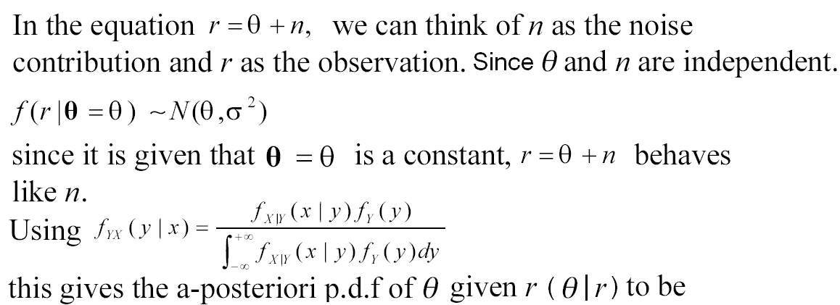
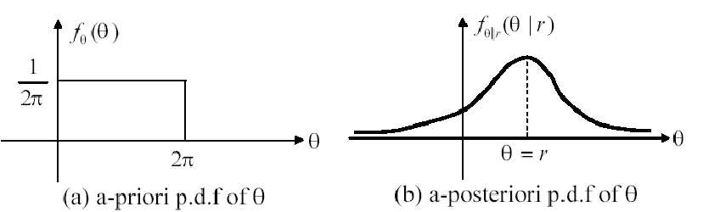
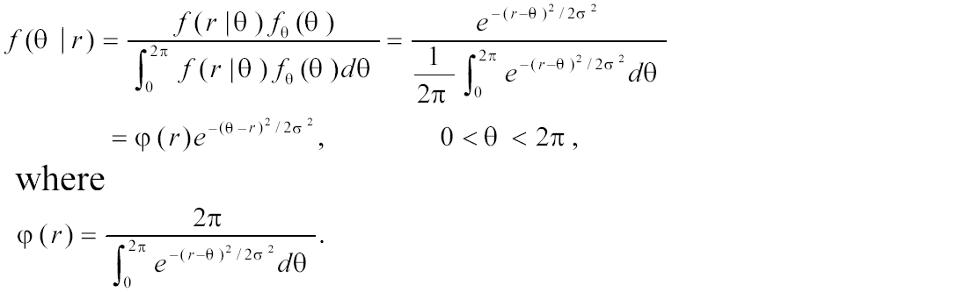

2. f_{XY} (x,y) = 2 / π , 0 ≤ x ≤ 1, 0 ≤ y ≤ π / 2.

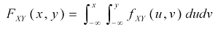
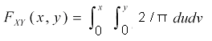
= 2 x y / π

P( 0< X < 0.5, 0< Y < π / 4) = F_{XY} (0.5, π / 4) - F_{XY} (0.5, 0) - F_{XY} (0, π / 4) +
F_{XY} (0,0)
= 1 / 4 - 0 - 0 - 0 = 1 / 4

3. E (y ) = E (x₁ + x₂ + x₃) = E (x₁) + E (x₂) + E (x₃) = 1 + 2 + 3 = 6.
Since x₁, x₂, x₃ are mutually uncorrelated, σ${}_{y}^{2}$ = σ${}_{x_{1}}^{2}$+ σ${}_{x_{2}}^{2}$+ σ${}_{x_{3}}^{2}$= 1 + 4 + 9 = 14.

4. E( y ) = E($\sum_{i=1}^{\text{1000}}{x_{i}}$) =$\sum_{i=1}^{\text{1000}}{}$E( x_{i} ) = $\sum_{i=1}^{\text{1000}}{}$0 = 0.

Var ( x_{i} ) =$\int_{−1}^{1}{}$(x - 0)² 0.5 dx = 0.5 (x³ / 3 )| ${}_{−1}^{1}$ = 1 / 3
Var ( y ) = σ${}_{y}^{2}$ = $\sum_{i=1}^{\text{1000}}{}$σ${}_{x_{i}}^{2}$= 1000 / 3.

Using Central Limit Theorem, y approaches Gaussian. Thus

f_{Y}(y) = (2000 π / 3 ) ^{–1/2} exp ( - 3 y ² / 1000 )

- E { [ x ( t + τ ) - x ( t ) ] ² } = E { [ x ( t + τ ) - x ( t ) ] [ x ( t + τ ) - x ( t ) ] }
= R_{xx}(0) - R_{xx}(τ) - R_{xx}(- τ) + R_{xx}(0)

Since R_{xx}(τ) is even, R_{xx}(τ) = R_{xx}(- τ) so
E { [ x ( t + τ ) - x ( t ) ] ² } = 2 [ R_{xx}(0) - R_{xx}(τ) ].

6. a. The random variable x ( t ) is Gaussian with zero mean and variance
E { x ² ( t ) } = R (0) = 4, hence it is N (0,4) and
P { x ( t ) ≤ 3 } = F_{x} (3) = G [ (3 – 0) / (4)^{1/2} ] = G (1.5) = 0.933
b. E { [ x ( t + 1 ) - x ( t - 1 ) ] ² } = 2 [ R(0) - R (2) ] = 8 ( 1 - e⁻⁴)

7. a. S_{yy}(ω) = S_{xx}(ω) | H(ω) | ² = 1. | [ exp ( j a ω ) - exp ( - j a ω ) ] | ²
= | 2 j sin (a ω) | ² = 4 sin ² (a ω).
- R_{xx} (τ) = [1 / (2 π ) ]$\int_{−∞}^{∞}{}$S_{xx} (ω) exp ( j ω τ ) d ω
= [1 / (2 π ) ]$\int_{−∞}^{∞}{}$1 . exp ( j ω τ ) d ω = δ (τ)
- S_{yy}(ω) = 4 sin ² (a ω) = 4 { (1/2) [1 - cos (2 a ω ) ] } = 2 [1-cos (2 a ω )]
= 2 - [ exp ( j 2 a ω ) + exp ( - j 2 a ω ) ] = 2 - exp (j2aω) - exp (-j2aω) R_{yy} (τ) = 2 R_{xx} (τ) - R_{xx} (τ + 2 a) - R_{xx} (τ - 2 a)
R_{yy} (τ) = 2 δ (τ) - δ (τ + 2 a) - δ (τ - 2 a)
- x ( t ) is white noise because its expected value is constant and its autocorrelation function is δ (τ), i.e., it has a flat power spectral density for all frequencies ω.
- y ( t ) is not white noise because its autocorrelation function is not δ(τ), i.e., it does not have a flat power spectral density for all frequencies ω.

  - $\overset{\hat{}}{X}$= E ( X |$\underset{−−}{Y}$) =$\int_{−∞}^{∞}{}$x f _{X | Y} ( x | y) dx
f _{X |Y} ( x | y) = f_{X Y} ( x | y) / f _{Y} (y)
f _{Y} (y) = $\int_{−∞}^{∞}{}$f_{X Y} ( x | y) dx = $\int_{0}^{1}{}$x y ² e ^{- y} dx = (1/2) y² e ^{– y} x ² |$\underset{0}{\overset{1}{}}$
= (1/2)y ² e ^{– y}
f _{X |Y} ( x | y) = f_{X Y} ( x | y) / f _{Y} (y) = x y ² e ^{– y} / [ (1/2)y ² e ^{– y} ] = 2 x

$\overset{\hat{}}{X}$= E ( X |$\underset{−−}{Y}$) =$\int_{−∞}^{∞}{}$x f _{X | Y} ( x | y) dx =$\int_{0}^{1}{}$x 2 x dx = (2/3) x ³ |$\underset{0}{\overset{1}{}}$= (2/3)

